1. What is thermodynamics?
2. What is heat transfer?
3. What is radiation? Give an example.
4. What is convection? Give an example.
5. What is conduction? Give an example.
6. What is thermal energy?
7. What is temperature?
8. Which depends on volume, thermal energy, or temperature?
9. Convert 105°F to Celsius.
10. Convert 50 °C to Fahrenheit. Show your work on the answer sheet.
11. Convert 3000C to Kelvin. Show your work on the answer sheet.
12. Convert 2530K to Celsius. Show your work on the answer sheet.
13. What is specific heat?
14. A substance that heats up relatively slowly has what, high or low specific heat?
15. Which of the following substances has a higher specific heat water or sand?

Use the graph to answer the following questions

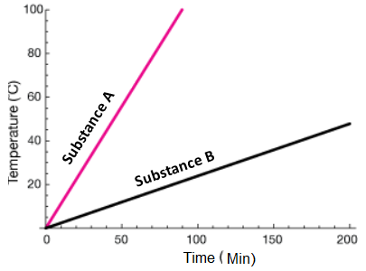

1. Which has a higher specific heat?
2. Which has a lower specific heat?
3. Which would heat up and cool down quickly?
4. Which would heat up and cool down slowly?
5. Use specific heat to explain why the sand on the beach is hotter than the water:
6. Do the following involves the addition of or removal of thermal energy?
   1. Boiling
   2. Melting
   3. Condensation
   4. Sublimation
   5. Deposition
   6. Freezing

**Use the graph to answer questions**

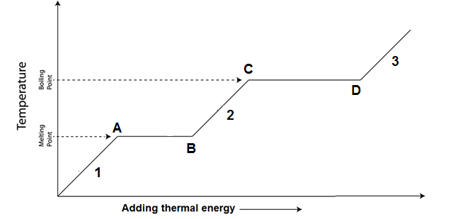

1. What do we know about the flat portion of a heating curve?
2. What do we know about the slanted (positive slope) portion of a heating curve?
3. What state is the substance in at 1?
4. What state is the substance in at 2?
5. What state is the substance in at 3?

**Answer the questions using the following heating curve.**

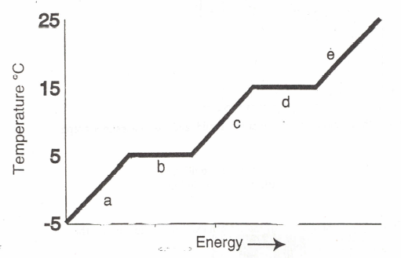

1. What is happening when the substance goes from A to B?
2. What is the freezing point temperature of the substance?
3. What is the boiling point temperature of the substance?
4. What is the melting point temperature of the substance?
5. What letter represents the range where the solid is being warmed?
6. What letter represents the range where the vapor/gas is being warmed?
7. What letter represents the range where the liquid is being warmed?
8. What letter represents the melting of the solid?
9. What letter represents the vaporization (boiling) of the liquid?
10. What letter represents condensation?
11. What letter represents freezing?